FOREX STOCK TREND PREDICTION FOR FOREX MARKETS USING MACHINE LEARNING APPROACH

ERICK MURU GITHINJI
SCT221-0972/2021

A Project Proposal submitted to the Department of Information Technology in the School of Computing and Information Technology in partial fulfillment of the requirement for the award of
Degree in Information Technology at Jomo Kenyatta University of Agriculture and Technology.
January, 2026

DECLARATION
I hereby declare that this project is original and has not been published or submitted for any other diploma or degree award to any other university before.

Student Name: ERICK MURU GITHINJI

Signature…………………..Date……………

This project has been submitted for examination with the approval by the Supervisor.

Supervisor Name: DR KABURU

Signature………………. Date………………

ACKNOWLEDGEMENT
First and foremost, I would like to express my gratitude to Almighty God for giving me a graceful bearing till this time of my life. Secondly, I thank my family for support in the process of carrying out my project. I am also grateful to my project supervisor, DR KABURU for guiding and helping me to carry out my project and acquire several skills that will help me in the project areas of related tasks.

Table of Contents
DECLARATION 2
ACKNOWLEDGEMENT 3
TABLE OF FIGURES 4
CHAPTER 3 5
SYSTEM ANALYSIS AND DESIGN 5
Introduction 5
Feasibility Study 5
REQUIREMENT ELICITATION 6
Data Analysis 8
SYSTEM SPECIFICATIONS 14
Functional Requirements 14
Non-Functional Requirements: 14
REQUIREMENTS ANALYSIS AND MODELLING 15
SYSTEM DESIGN 19
Logical design 19
System architecture 20
Physical design 21
User Interface Designs. 21
System mockups. 23

TABLE OF FIGURES
Figure 1 Activity diagram 18
Figure 2 Use case Diagram 19
Figure 3 Sequence diagram 20
Figure 4 logical Design 21
Figure 5 System Architecture 22
Figure 6 User interface home page 24
Figure 7 Prediction page 25
Figure 8 system mockup 26
Figure 9 Predicted prices 26
Figure 10 predicted trend 27
Figure 11 Calculated moving averages form 28

CHAPTER 3

SYSTEM ANALYSIS AND DESIGN

Introduction
This chapter covered system methodology, requirement elicitation which helped in data collection of user and system requirements, and feasibility study all this which clearly gave me the overall image of how the system should look and operate. System analysis projects are initiated for three reasons: problems, opportunities, and directives. It also covered functional and non-functional system requirements, system logical design using Unified Modelling Language (UML) diagrams, and system physical design, including database design and user interface design.

Feasibility Study
A feasibility study is a crucial step to assess the practicality and viability of the proposed project. It involves evaluating the economic, technical, and other critical aspects to determine whether the project can be successfully implemented.
- Economic Feasibility
The cost estimates for developing the system are within budget while the benefits include, improved product quality leading to increased profits and customer satisfaction, potential cost savings through automated quality assessment and enhanced competitiveness in the stock market.
In cost Analysis, the implementation cost for developing the system, acquiring necessary hardware, software, and training, was analyzed. The budget allocation was found to be within the defined financial resources of Continental forex beaural limited. About the return on Investment (ROI), a conservative estimate was calculated, factoring in potential increased efficiency and reduced losses due to better quality control.
Return on Investment (ROI):
Total Costs:
Initial Investment (Development + Deployment): 40,000 KES + 40,000 KES = 80,000 KES
Annual Maintenance Costs: 22,000 KES
Net Annual Benefit:
Additional Trading Profits: 45,000 KES
Maintenance Costs: 22,000 KES
Net Annual Benefit: 45,000 KES - 22,000 KES = 23,000 KES
ROI:
ROI = (Net Annual Benefit / Total Costs) * 100%
ROI = (23,000 KES / 80,000 KES) * 100% ≈ 28.75% The ROI calculations suggested a favorable return within a reasonable timeframe, making the project economically feasible.
- Technical feasibility
The technical infrastructure and technologies required for the stock prediction system were assessed. Assessing the availability of data sources needed for stock forecasting, such as historical stock prices, financial statements, economic indicators, news sentiment data, and alternative data sources. It also involved evaluating the viability of data collection, cleaning, and preprocessing methods. Considering the computational resources and infrastructure required to build and maintain the stock prediction system, including hardware, software, and data storage. It was determined that the necessary hardware and software could be readily obtained and integrated into the existing IT infrastructure of the organization. The system was also deemed scalable to handle a growing volume of stocks. Moreover, the system architecture allowed for future upgrades and integration with emerging technologies.
- Operational Feasibility
The integration of the stock prediction system with existing workflow processes was evaluated. This involved assessing the practicality of integrating the stock prediction system into existing workflows and decision-making processes of target users. Evaluating user acceptance and usability considerations, such as the user interface design, ease of interpretation of predictions, and integration with trading platforms or investment management systems. The study found that the system could be seamlessly integrated into other organizations programs, ensuring minimal disruption to other existing operational flow. The system was seen as a valuable tool to streamline the evaluation process and enhance decision-making.
- Legal and Ethical Feasibility
The system will comply with all legal and ethical standards regarding data privacy, intellectual property, and usage rights. The study ensured that the system and its operations complied with Investment and Financial Analysts Act related to data privacy, intellectual property, and usage of stock data. The project aims to contribute positively to society by potentially reducing the rate at which new stock investors lose their money due to lack of knowledge.
- Schedule Feasibility
A detailed project timeline was developed, taking into account the complexity of the development process and potential challenges. The study confirmed that the project could be completed within the stipulated timeframe.

REQUIREMENT ELICITATION
The primary data collection tool for this project was interviews, questionnaires and reviewing of existing systems. Data collection also involved getting data from secondary sources of data like online repositories. The data chosen was specifically of the highly traded stocks. This was done to ensure that the data obtained from secondary sources matched the primary data collected from the client. More so, this ensured that the model was trained on the same type of data but from different sources. Data collection was administered by getting views from the client ad also online repositories which is yahoo finance which provided the stock data of the current stock market.
Yahoo finance
Yahoo Finance is a comprehensive financial news and data platform provided by Yahoo, a multinational technology company. It offers a wide range of financial information, including stock quotes, financial news, analysis, portfolio management tools, and market data. Users can access real-time stock quotes, historical price charts, financial statements, analyst ratings, and other investment-related information for thousands of publicly traded companies worldwide. The data set for training the module was acquired from this repository.

Stock dataset
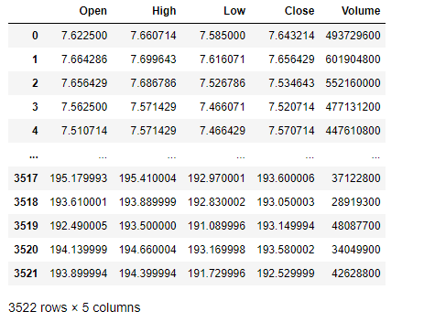

Table 1 Data distribution

Stock company and stock symbols as used in stock market
COMPANY | SYMBOL
Google | GOOGL
Apple | AAPL
Amazon | AMZN
Microsoft | MSFT
Tesla | TSLA
Table 2 Company name and its stock ticker
We'll use this data to predict and forecast the worth of days into the future. Then we'll use the simplest Machine Learning Algorithm to predict the longer-term stock values in any company stock or other financial instrument traded on a financial exchange.

Data Analysis
The data was analyzed and interpreted using an Excel spreadsheet and the results displayed as illustrated below This section contains a continuation of the analysis of respondents concerning the non-functional requirements of the system as well as the interactivity of the software.
The total amount of stock data gathered for this dataset was 3522 files which are grouped into stocks opening price named open, stock closing price as close highest reading Ina day as high, lowest reading in a day as low and the volume of the stock as volume.
QUESTIONS ASKED AT CONTINENTAL FOREX BEURAL LTD
- What are your primary objectives in seeking a stock prediction system?
- Can you describe the specific challenges or pain points you're facing in your current approach to stock trading or investment decision-making?
- What are the key features or functionalities you expect from the stock prediction system?
- How do you envision integrating the stock prediction system into your existing workflow or investment strategy?
- Do you have any preferences or requirements regarding the presentation or visualization of stock prediction results?
- How would you rate the success of new stock investors according to your yearly data?
- What level of accuracy or reliability do you expect from the stock prediction system?
QUESTIONAIRE

- How would you describe your level of experience with stock markets and trading?
- No experience
- Beginner
- Experienced trader

- Have you used any other stock prediction systems before?

- Yes
- No

- In a scale how would you expect the user interface of the stock prediction system in terms of user-friendliness?

- 0
- 1
- 2
- 3
- 4
- 5

- How do you prefer to receive output of a stock trend?

- Inform of a graph showing trend
- Closing price numbers

- On a scale of 1-5, how important is it for you to have a reliable and trustworthy web-based stock prediction system? (1 - Not important at all, 5- Extremely important)
- 0
- 1
- 2
- 3
- 4
- 5

- What level of accuracy or prediction performance are you expecting from the system?
- 0
- 1
- 2
- 3
- 4
- 5
- 6
- 7
- 8
- 9
- 10

- Do you prefer the system to be fully automated, semi-automated, or used as a decision support tool alongside human judgment?
- Fully automated
- Semi-automated,
- Decision support tool alongside human judgment?

- On a scale of 1 -10 how important is data security and confidentiality for you?
- 1
- 2
- 3
- 4
- 5
- 6
- 7
- 8
- 9
- 10

On a scale of 1-5, how important is it for you to have a reliable and trustworthy web-based stock prediction system? (1 - Not important at all, 5- Extremely important)
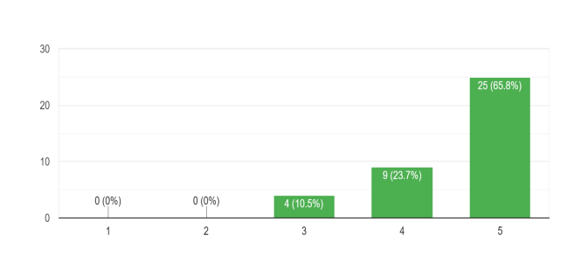
This analysis deduced that the respondents value an efficient channel that enables them to analyze and predict the stock trend easily.
How do you prefer to receive output of a stock trend?
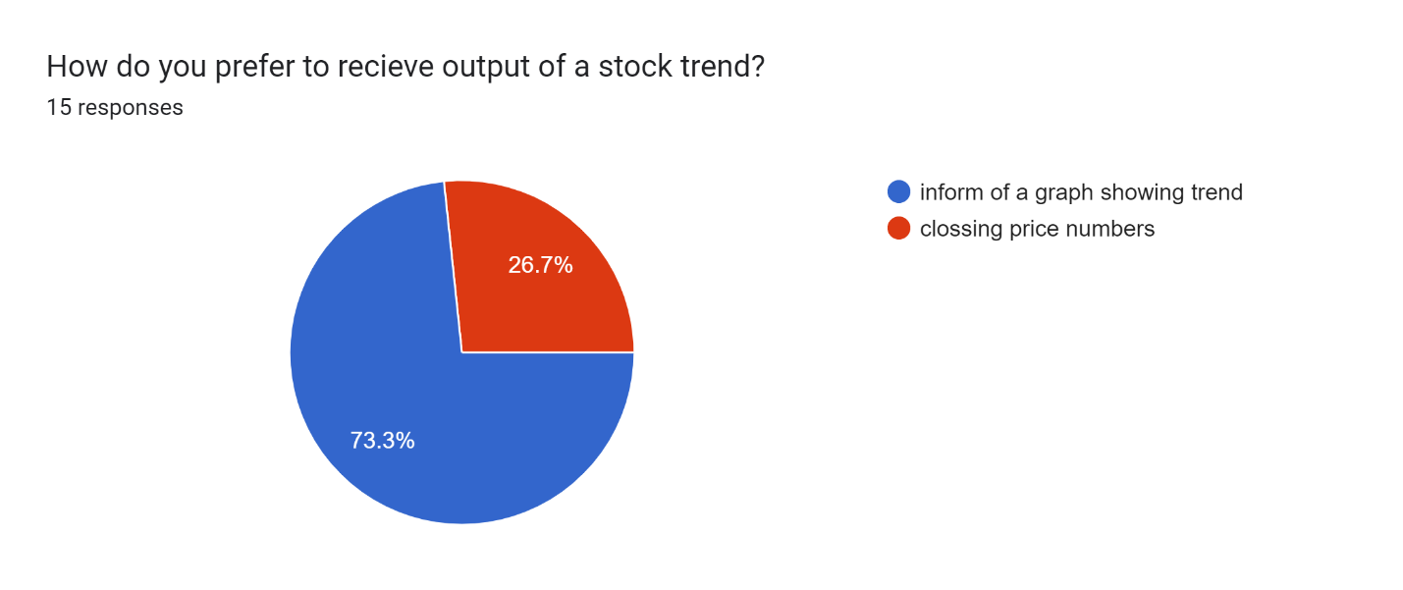
This analysis deduced that the respondents would a appreciate a system that will provide for them a stock trend in form of a graph.

How would you rate the succes rate o new stock investors inthe market acording to your yealy data

It was evident that new stock traders in the market are more likely to blow their accounts dues to lack of assistance and the difficulty in analyzing the stock trend.
How would you like a stock prediction system to provide output to you

The findings of this analysis deduced that the responders are truly faced by various challenges in their quest for stock prediction.

SYSTEM SPECIFICATIONS
System specification refers to a detailed description of the requirements, functionalities, and characteristics of a system. It outlined the specific features, behaviors, and constraints that the system should possess to meet the desired objectives and fulfill the needs of its users.

Functional Requirements
Functional requirements refer to what the system does. In this system they include;
- Accept user input
- Fetch historical stock data from yahoo finance
- Preprocess the collected data by handling missing values and feature extraction
- Train machine learning models using the preprocessed historical data to predict future stock prices
- Generate predictions for future stock prices based on the trained models.
- Plot both stock data and predicted stock prices
- Plot weekly, daily and monthly stock trends
- Allow integration with external systems or APIs for accessing real-time data and incorporating it into the prediction models.

Non-Functional Requirements:
- Performance: The system should be able to handle large volumes of data efficiently and produce predictions within a reasonable timeframe.
- Accuracy: The prediction models should strive for high accuracy in forecasting stock prices to provide reliable insights to users.

- Scalability: The system should be scalable to accommodate increasing data volume and user demand without sacrificing performance.
- Reliability: Ensure high reliability by minimizing system downtime and errors, providing failover mechanisms, and implementing data backup strategies.
- Security: Implement robust security measures to protect sensitive financial data and user information from unauthorized access, breaches, or cyberattacks.
- Usability: Design the system with a user-friendly interface and intuitive navigation to facilitate ease of use for users with varying levels of technical expertise.
- Compatibility: Ensure compatibility with different platforms and devices to allow users to access the system from desktops, tablets, and smartphones.
- Maintainability: Design the system with clean, modular code and documentation to facilitate easy maintenance, updates, and troubleshooting by developers.
- Regulatory Compliance: Ensure compliance with relevant regulations and standards governing financial data handling and prediction systems.
- Ethical Considerations: Incorporate ethical considerations into the system's design and operation, such as transparency in model assumptions, avoiding bias in predictions, and respecting user privacy.

REQUIREMENTS ANALYSIS AND MODELLING
Requirement’s modeling is a technique used in software engineering and systems analysis create
visual representations or models that depict the various aspects of the system's requirements,
such as its functionality. This process of modeling involved using applications such as lucid char and plantuml web server.
Activity diagram
This activity diagram captures the main steps involved in the stock prediction process using an LSTM model and provides a clear flow of activities from user input to output.

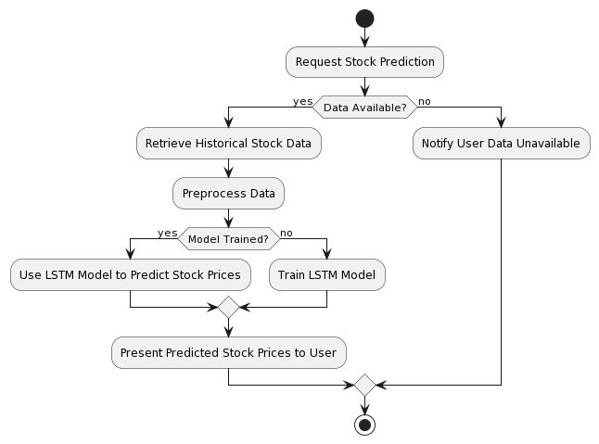
Figure 1 Activity diagram

- The user initiates the process by requesting a stock prediction.
- The system checks if historical stock data is available. If it is, the system proceeds with retrieving and preprocessing the data.
- If the LSTM model is already trained, the system directly uses it to predict stock prices. Otherwise, it trains the LSTM model first.
- Finally, the predicted stock prices are presented to the user. If no data is available, the user is notified accordingly.

Use Case Diagram
This diagram depicts the interactions between actors and the system, illustrating the system’s
functionality from the user’s perspective
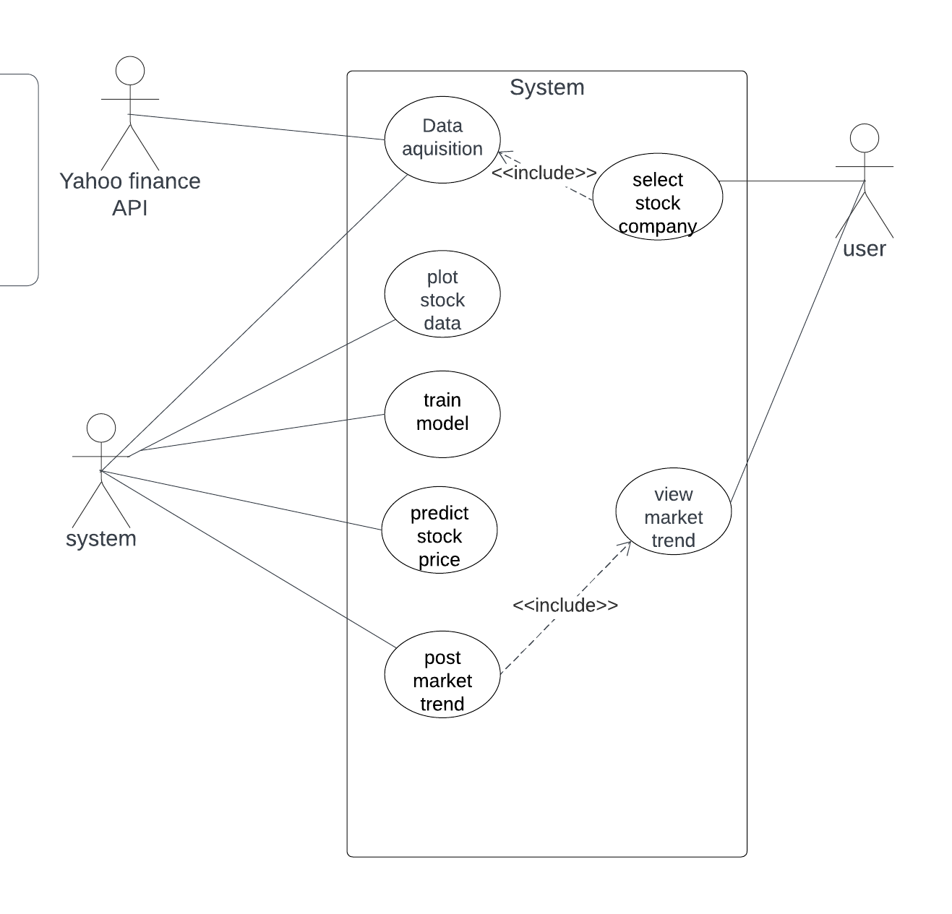
Figure 2 Use case Diagram

Sequence Diagram
These sequence diagrams show the flow of messages and interactions between objects or
components over time. They represent the dynamic behavior of a system by illustrating the
sequence of interactions between different entities. The diagrams representing objects or components, and horizontal arrows representing messages exchanged
between them. The sequence of messages is shown chronologically, allowing for a clear
understanding of the order of interactions.
Below are two sequence diagrams on illustrating the order of events for the stock investor.

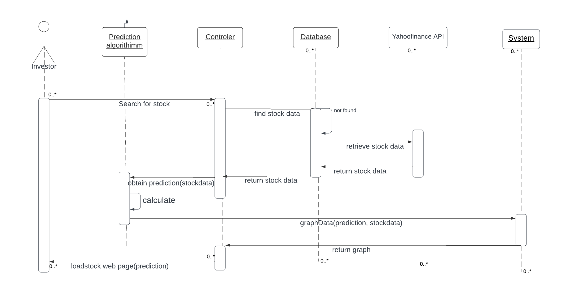
Figure 3 Sequence diagram

The sequence diagram shows that the system follows the following steps:
- The user enters the stock name.
- The application sends the stock name to the server application.
- The server application processes the stock ticker to extract relevant features.
- The server application uses the machine learning model to predict the stock trend.
- The server application sends the results back to the client application.
- The client application displays the results to the user.

SYSTEM DESIGN
This section gives a complete overview of the system architecture shown in Figure 1 and the process flow diagram of the system gives in detail with a diagram and information

Logical design

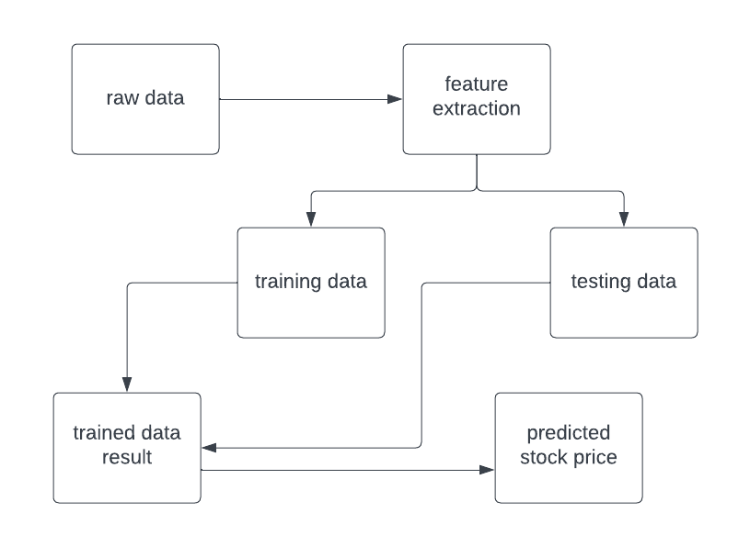
Figure 4 logical Design
Yahoo finance It is likewise have dataset for distinctive fields. Various statistics scientist competes to create the nice fashions for predicting. It permits the consumer to gather the dataset for the predicting process. To resolve the actual time statistics technological know-how challenge. The dataset used on this challenge has been downloaded from yfinance. The dataset accrued in uncooked format. Stock fee dataset of few agencies has been accrued. The first step is to gather the uncooked inventory charge facts and preprocess the facts

System architecture
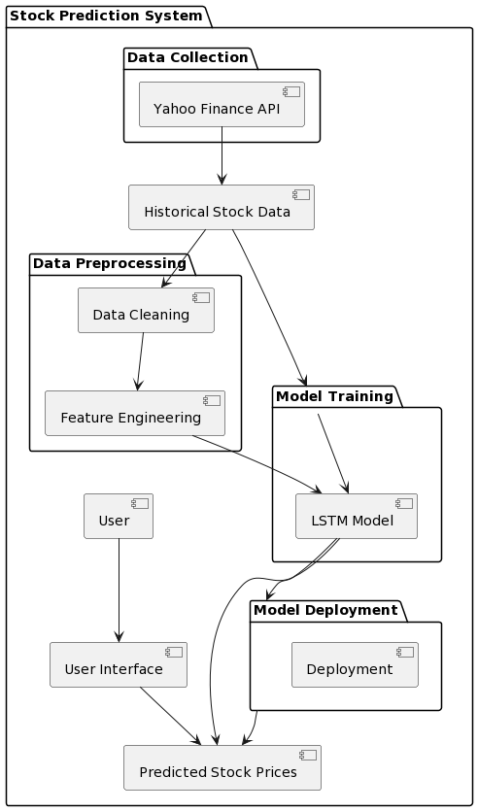
Figure 5 System Architecture
- Data Collection: The Yahoo Finance API collects historical stock data.
- Data Preprocessing: The collected data goes through cleaning and feature engineering processes.
- Model Training: The preprocessed data is used to train the LSTM model.
- Model Deployment: The trained model is deployed for prediction.
- User Interface: Users interact with the system to get predicted stock prices.
- Data Flow: Historical stock data flows through data preprocessing and model training to generate predicted stock prices, which are then presented to the user through the user interface.

Physical design

User Interface Designs.
The system will have a web application interface to allow for taking use input that will be sent to the machine learning model for prediction of trend. The interface will also display results to the user.
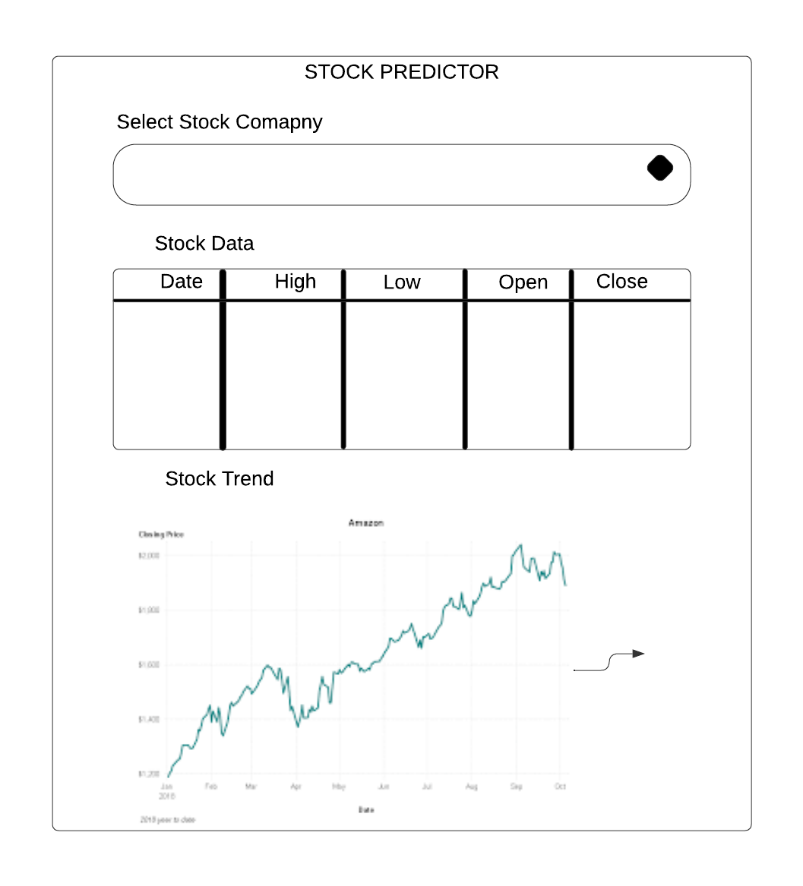
Figure 6 User interface home page
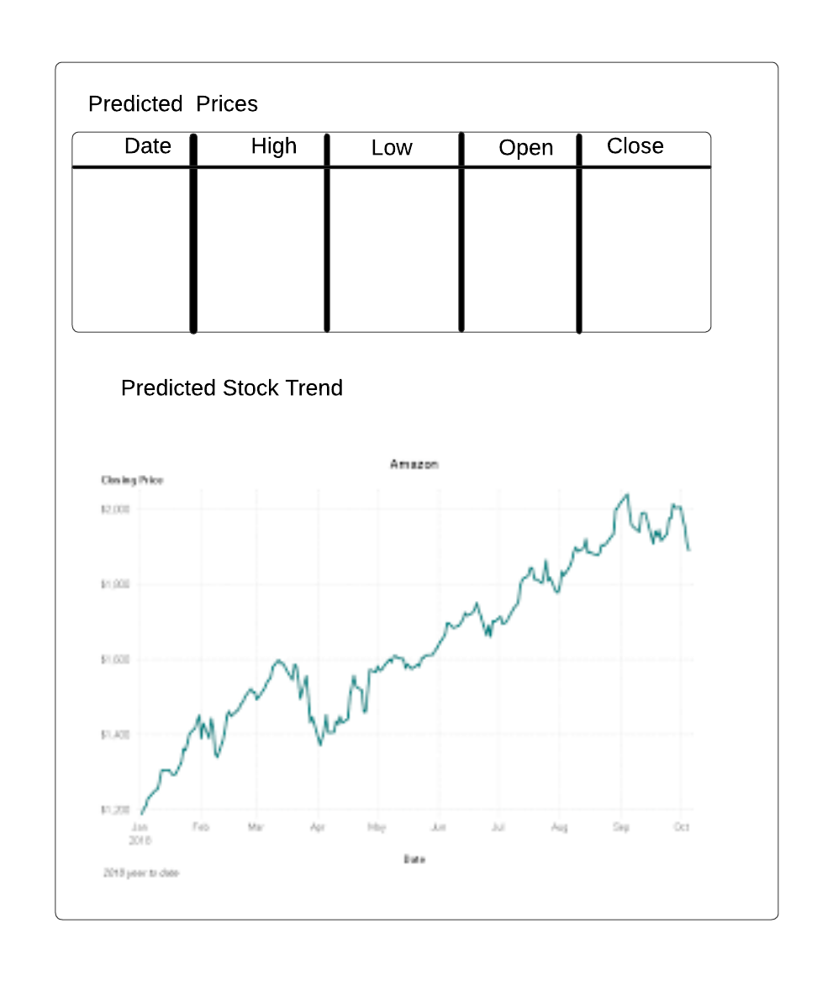
Figure 7 Prediction page

System mockups.
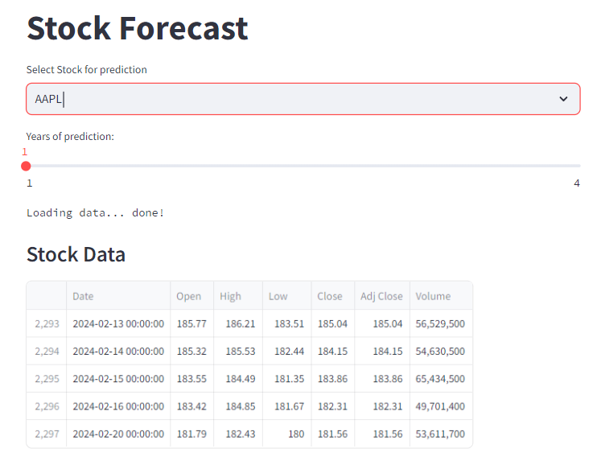
Figure 8 system mockup
when the user or investor accesses the system, this will be his/her landing page also the welcome page. In this page the user can select the stock name he or she would like to see the prediction.
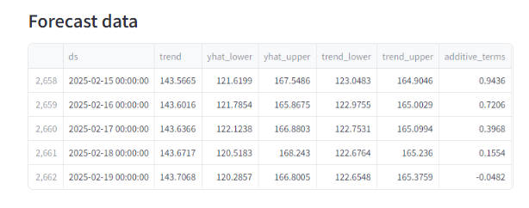
Figure 9 Predicted prices

After the user selects a stock to predict they will be provided with a forecast table of the predicted closing high and low stock prices.
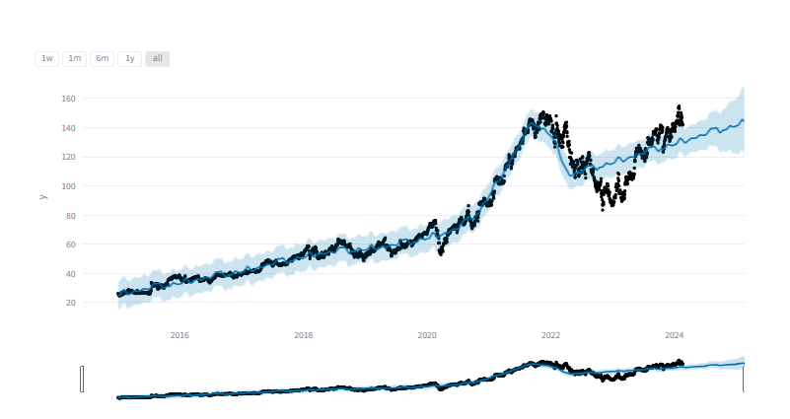
Figure 10 predicted trend

The system will also provide the user with a graph of the trend. This will be plotted where prediction against the actual stock price.
The system will also provide a 100 and 200 days moving average indicator for the user so as to assist in checking the accuracy of the predicted trend as shown below.
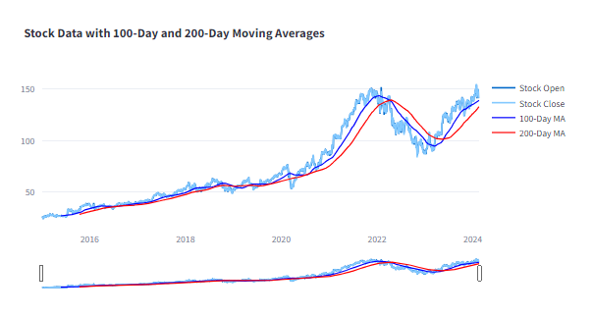
Figure 11 Calculated moving averages form

